Economics

**Chapter One: Microeconomics**

**1.1 Introduction to Economics**

**1.1.1 Definition of Economics**

Economics is the social science that studies how individuals, businesses, governments, and societies allocate scarce resources to satisfy unlimited wants and needs. It analyzes how decisions are made regarding production, distribution, and consumption of goods and services. Economics encompasses various fields such as microeconomics, which focuses on individual decision-making units like households and firms, and macroeconomics, which examines the broader aggregates such as national income, unemployment, and inflation.

**1.1.2 Basic Economic Concepts: Economic Resources, Human Wants, Scarcity and Choice, Opportunity Cost, Production Possibility Curves/Frontiers**

Economic Resources: Economic resources, also known as factors of production, are the inputs used to produce goods and services. They include land (natural resources), labor (human effort), capital (physical and human-made resources used in production), and entrepreneurship (the ability to combine the other resources to create goods and services).

Human Wants: Human wants are the desires for goods and services that people have, which are unlimited. These wants range from basic necessities like food, clothing, and shelter to more complex desires such as luxury items and entertainment.

Scarcity and Choice: Scarcity refers to the limited availability of resources relative to the unlimited wants and needs of society. Because resources are scarce, individuals, businesses, and governments must make choices about how to allocate them efficiently. This involves prioritizing among competing wants and needs.

Opportunity Cost: Opportunity cost is the value of the next best alternative forgone when a decision is made. It represents the cost of choosing one option over another. In other words, whenever a choice is made, the opportunity cost is the value of what is sacrificed.

Production Possibility Curves/Frontiers: A production possibility curve (PPC), also known as a production possibility frontier (PPF), illustrates the maximum output combinations of two goods or services that an economy can produce given its resources and technology. It shows the trade-offs between producing different goods or services. Points on the curve represent efficient use of resources, while points inside the curve indicate underutilization and points outside the curve are unattainable given current resources and technology.

**1.1.3 Scope of Economics: Micro and Macro Economics**

Microeconomics: Microeconomics focuses on the behavior of individual economic agents, such as households, firms, and industries, and the markets in which they operate. It examines how these agents make decisions regarding the allocation of resources, consumption, production, and pricing of goods and services. Key topics in microeconomics include supply and demand, market structures (such as perfect competition, monopoly, and oligopoly), consumer behavior, production costs, and factors influencing individual decision-making, such as utility maximization and profit maximization.

Macroeconomics: Macroeconomics, on the other hand, deals with the economy as a whole and examines aggregate phenomena such as national income, output, employment, inflation, and economic growth. It analyzes the overall performance of the economy and the factors that influence it, such as government policies, monetary and fiscal policies, international trade, and globalization. Macroeconomics aims to understand and address issues like unemployment, inflationary pressures, business cycles, and long-term economic growth. Key macroeconomic concepts include gross domestic product (GDP), inflation rate, unemployment rate, aggregate demand and supply, fiscal policy, monetary policy, and international trade.

Both microeconomics and macroeconomics are essential for understanding the functioning of economies and formulating effective economic policies. While microeconomics focuses on individual economic units and their interactions, macroeconomics provides a broader perspective by examining aggregate economic variables and their implications for the overall economy. Together, these two branches provide insights into different aspects of economic behavior and help policymakers, businesses, and individuals make informed decisions in various economic contexts.

**1.1.4 Methodology of Economics: Positive and Normative Economics, Scientific Methods, Economics as a Social Science**

The methodology of economics encompasses various approaches to studying economic phenomena, including positive and normative economics, scientific methods, and the recognition of economics as a social science.

Positive Economics: Positive economics focuses on describing and explaining economic phenomena as they are, without making value judgments or prescribing what ought to be. It aims to provide objective analysis based on empirical evidence and economic theories. Positive economics seeks to answer questions such as "What is the effect of a minimum wage increase on employment?" or "How does an increase in interest rates impact investment?" Positive statements can be tested and verified through observation and data analysis.

Normative Economics: Normative economics, on the other hand, involves value judgments and deals with questions of what ought to be or what economic policies should be pursued. It reflects subjective opinions about what is desirable or undesirable in economic outcomes. Normative statements often involve moral, ethical, or political considerations and cannot be tested or proven true or false in the same way as positive statements. Examples of normative questions include "Should the government increase taxes on the wealthy to reduce income inequality?" or "Is free trade beneficial for society?"

Scientific Methods: Economics employs various scientific methods to study economic phenomena, including observation, experimentation, statistical analysis, and mathematical modeling. Economists collect data, formulate hypotheses, and test theories using empirical evidence. They also use mathematical and statistical tools to analyze relationships between variables and make predictions about economic behavior. Economic models, such as supply and demand models or macroeconomic models, are used to simplify complex economic systems and understand their underlying mechanisms.

Economics as a Social Science: Economics is considered a social science because it deals with human behavior and interactions within social structures. It examines how individuals, households, firms, and governments make decisions and interact in markets and economies. Like other social sciences, economics considers the influence of cultural, institutional, and historical factors on economic outcomes. It also recognizes the complexity and diversity of human behavior, which may not always conform to traditional economic models.

By combining positive and normative analysis, employing scientific methods, and recognizing economics as a social science, economists aim to provide a comprehensive understanding of economic phenomena and inform policy decisions to improve societal welfare.

**1.1.5 Economic Systems: Planned Economy, Free Market Economy, Mixed Economy**

Economic systems refer to the institutional arrangements and mechanisms through which societies allocate resources, produce goods and services, and distribute them among individuals and groups. The main types of economic systems are planned economies, free market economies, and mixed economies.

**Planned Economy (Command Economy)**

* In a planned economy, the government or a central authority makes most or all economic decisions. The government owns and controls the means of production, such as land, labor, and capital, and determines what goods and services are produced, how they are produced, and for whom they are produced.
* Planning authorities set production targets, allocate resources, and coordinate economic activities according to central plans and priorities. Prices may be set by the government rather than determined by supply and demand in markets.
* Examples of planned economies include the former Soviet Union, North Korea, and Cuba.

**Free Market Economy (Capitalist Economy)**

* In a free market economy, economic decisions are decentralized and made by individuals, households, and businesses operating in markets. The government's role is limited to enforcing property rights, contracts, and regulations to ensure competition and prevent market failures.
* Private ownership of resources and the means of production is predominant, and prices are determined by supply and demand in competitive markets. Individuals and firms pursue their self-interest, and the invisible hand of the market guides resource allocation and production decisions.
* Examples of free market economies include the United States, Hong Kong, and Singapore.

**Mixed Economy**

* A mixed economy combines elements of both planned and free market systems. In a mixed economy, the government intervenes in markets to achieve specific social or economic objectives, such as promoting social equity, ensuring economic stability, or correcting market failures.
* The degree of government intervention varies across mixed economies, with some allowing more extensive government involvement in economic activities than others. Governments may provide public goods and services, regulate industries, redistribute income through taxes and welfare programs, and engage in macroeconomic stabilization policies.
* Many modern economies, including those of the United Kingdom, Canada, and Germany, are considered mixed economies.

Each type of economic system has its advantages and disadvantages, and the choice of system depends on societal values, historical context, and policy objectives. While planned economies can achieve rapid industrialization and prioritize social welfare, they often suffer from inefficiency, lack of innovation, and bureaucratic inefficiencies. Free market economies, on the other hand, are characterized by efficiency, innovation, and consumer choice but may lead to income inequality, market failures, and social disparities. Mixed economies seek to combine the strengths of both systems while mitigating their weaknesses, aiming to achieve economic growth, social stability, and equitable outcomes.

**1.1.6 Consumers Sovereignty and its Limitations**

Consumer sovereignty is a concept in economics that asserts that consumers ultimately determine what goods and services are produced in an economy through their purchasing decisions. In other words, in a market economy, producers respond to consumer preferences and demand by producing the goods and services that consumers are willing and able to buy. Consumer sovereignty is a central tenet of free market economics and is often cited as one of the key advantages of market-based systems.

However, consumer sovereignty is not without limitations. Here are some key factors that can limit consumer sovereignty:

Income and Wealth Inequality: In societies with significant income and wealth inequality, consumer sovereignty may be limited by the purchasing power of different income groups. Wealthier consumers may have more influence over what goods and services are produced, while lower-income consumers may have less ability to shape market outcomes.

Information Asymmetry: In many markets, consumers do not have perfect information about the products they are buying, their quality, or the true costs associated with their production. This information asymmetry can limit consumer sovereignty by leading to suboptimal decisions and market outcomes.

Market Power: In markets dominated by a few large firms or monopolies, consumer sovereignty may be limited by the market power of these producers. Monopolistic firms can manipulate prices, limit choice, and reduce consumer welfare by restricting competition and innovation.

Externalities: Externalities are unintended consequences of economic activities that affect third parties who are not directly involved in the transaction. Positive externalities, such as the benefits of education or vaccination, or negative externalities, such as pollution or congestion, can lead to market failures and limit consumer sovereignty by distorting prices and incentives.

Public Goods and Services: Certain goods and services, such as national defense, public infrastructure, and environmental protection, are not efficiently provided by the market due to their non-excludable and non-rivalrous nature. In such cases, consumer sovereignty may be limited, and government intervention may be necessary to ensure the provision of these public goods.

Cultural and Social Factors: Consumer preferences are influenced by cultural norms, social expectations, and advertising, which may not always reflect individual preferences or promote consumer welfare. In some cases, societal pressures or cultural biases may limit consumer sovereignty by shaping purchasing decisions.

While consumer sovereignty is a powerful force in market economies, these limitations highlight the need for government regulation, consumer protection policies, and social interventions to address market failures, promote competition, and ensure that markets serve the broader interests of society.

**1.2 Demand, Supply and Determine Equilibrium**

**1.2.1 Demand Analysis**

**1.2.1.1 Definition of Demand**

Demand in economics refers to the quantity of a good or service that consumers are willing and able to purchase at various prices during a specific period, ceteris paribus (all other factors being equal). It represents the relationship between the price of a product and the quantity demanded by consumers.

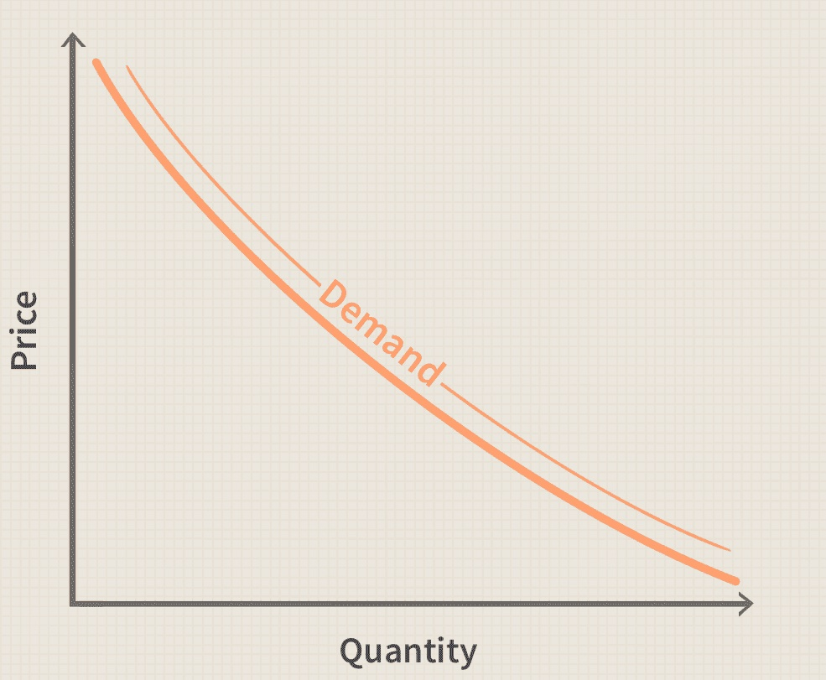

**1.2.1.2 Law of Demand**

The law of demand is a fundamental principle in economics that describes the inverse relationship between the price of a good or service and the quantity demanded by consumers, ceteris paribus (all other factors being equal). In other words, as the price of a product increases, the quantity demanded decreases, and as the price decreases, the quantity demanded increases, assuming that all other factors influencing demand remain constant.

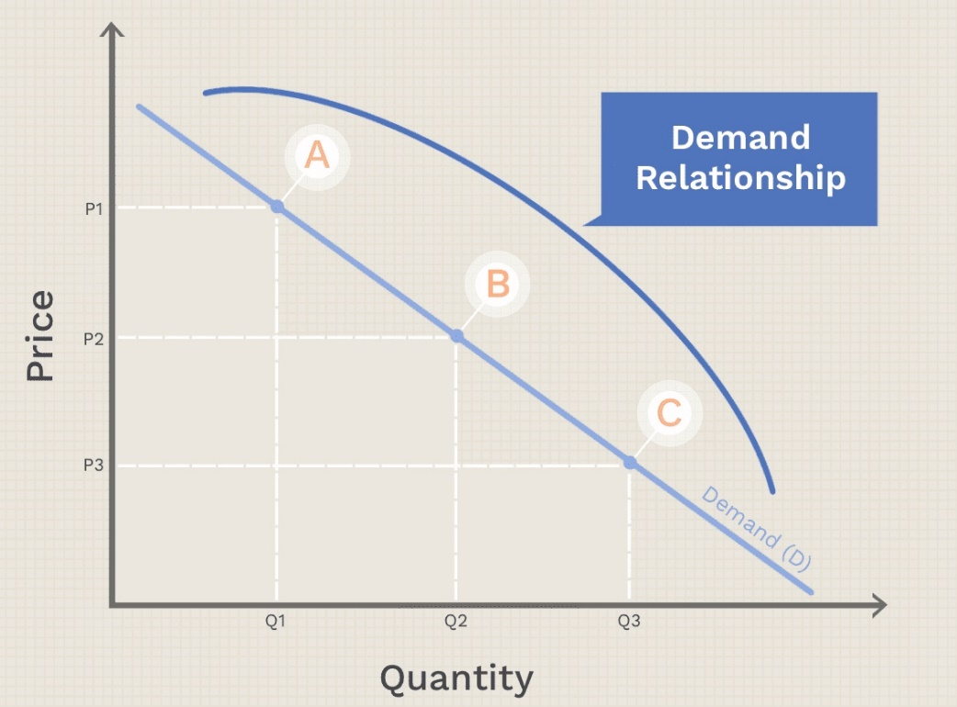

By adding up all the units of a good that consumers are willing to buy at any given price, we can describe a market demand curve, which is always sloping downward, like the one shown in the chart below. Each point on the curve (A, B, C) reflects the quantity demanded (Q) at a given price (P). At point A, for example, the quantity demanded is low (Q1) and the price is high (P1). At higher prices, consumers demand less of the good, and at lower prices, they demand more.

Key aspects of the law of demand include:

Negative Slope: The law of demand is typically depicted graphically as a downward-sloping demand curve, where the horizontal axis represents the quantity demanded and the vertical axis represents the price of the product. The negative slope of the demand curve reflects the inverse relationship between price and quantity demanded.

Income and Substitution Effects: The negative slope of the demand curve can be explained by two main effects:

Income Effect: As the price of a product decreases, consumers' purchasing power increases, allowing them to buy more of the product with their existing income. Conversely, when the price increases, consumers' purchasing power decreases, leading to a reduction in quantity demanded.

Substitution Effect: When the price of a product decreases, it becomes relatively cheaper compared to alternative goods, leading consumers to substitute it for more expensive goods. This substitution effect contributes to an increase in quantity demanded at lower prices.

Assumptions and Limitations: The law of demand is based on the ceteris paribus assumption, which means that it holds true only if all other factors influencing demand remain constant. In reality, various factors such as consumer preferences, income levels, prices of related goods, and external economic conditions can affect demand and potentially lead to exceptions to the law of demand.

Empirical Evidence: The law of demand is supported by empirical evidence from real-world markets and is observed across a wide range of goods and services. Economists and policymakers often rely on the law of demand to analyze consumer behavior, predict market responses to price changes, and formulate economic policies.

Overall, the law of demand is a fundamental concept in economics that provides valuable insights into consumer behavior and market dynamics. It highlights the importance of price elasticity of demand and the role of prices in allocating scarce resources efficiently in market economies.

**1.2.1.3 Exceptional Demand versus Market Demand**

"Exceptional demand" and "market demand" are terms used in economics to describe different aspects of the demand for goods and services:

**Exceptional Demand**

Exceptional demand refers to the demand for a particular good or service that is driven by unique or extraordinary circumstances, rather than the typical factors that influence demand. This type of demand often arises in response to unexpected events or changes in the external environment, such as natural disasters, emergencies, or sudden shifts in consumer preferences. Exceptional demand can lead to temporary spikes in the quantity demanded for specific products, often resulting in shortages or surpluses in the market. Examples of exceptional demand include increased demand for bottled water and emergency supplies during a hurricane, or higher demand for winter clothing during an unseasonably cold winter.

Exceptional demand refers to situations where the demand for a particular good or service deviates from the typical patterns observed under normal economic conditions. Here are some examples of exceptional demand:

**a) Giffen Paradox**

The Giffen paradox is a situation where an increase in the price of a good leads to an increase in demand for that good, contrary to the law of demand. This phenomenon occurs when the good in question is an inferior good, meaning that consumers buy more of it as their income decreases. The classic example often used to illustrate the Giffen paradox is the case of staple food items, such as rice or potatoes, in impoverished communities. When the price of these goods rises, consumers, who are already struggling to afford basic necessities, may be forced to allocate a larger portion of their limited income to purchasing these goods, leading to an increase in demand despite the higher price.

**b) Veblen Goods**

Veblen goods are luxury goods for which demand increases as their price increases, contrary to the law of demand. This phenomenon occurs because the higher price of the good is perceived as a signal of higher quality, status, or exclusivity, leading to increased demand among certain consumers. Examples of Veblen goods include luxury cars, designer clothing, and high-end jewelry. Consumers may purchase these goods not only for their intrinsic utility but also for their symbolic value and status-enhancing effects.

**c) Ignorance**

Ignorance-driven exceptional demand occurs when consumers lack complete information about the characteristics, qualities, or prices of goods or services. In such cases, consumers may demand products at prices that they perceive to be fair or reasonable, even if those prices do not accurately reflect the true value of the goods. This type of exceptional demand is more likely to occur in markets with imperfect information, limited transparency, or where consumers have limited access to alternative choices or substitutes.

**d) Speculation**

Speculative demand occurs when consumers purchase goods or assets with the expectation that their prices will increase in the future, allowing them to sell at a profit. Speculative demand can lead to price bubbles and asset booms, where demand exceeds fundamental values driven by expectations of future price increases. Speculative demand can be observed in various markets, including real estate, stocks, and cryptocurrencies, where investors may buy assets with the intention of selling them at higher prices in the future, rather than for their intrinsic utility or use value.

**e) Fear of Shortage**

Fear-driven exceptional demand occurs when consumers anticipate shortages of certain goods or services due to perceived or actual threats, such as natural disasters, political unrest, or supply chain disruptions. In response to these fears, consumers may rush to purchase essential items in anticipation of future shortages, leading to panic buying and stockpiling. This type of exceptional demand can exacerbate shortages, create artificial scarcity, and disrupt market equilibrium, as seen during events like hurricanes, pandemics, or economic crises. These examples illustrate how exceptional demand can arise under various circumstances, often deviating from the typical patterns predicted by standard economic models. Exceptional demand underscores the complexity of consumer behavior and the importance of considering psychological, sociological, and contextual factors in understanding market dynamics.

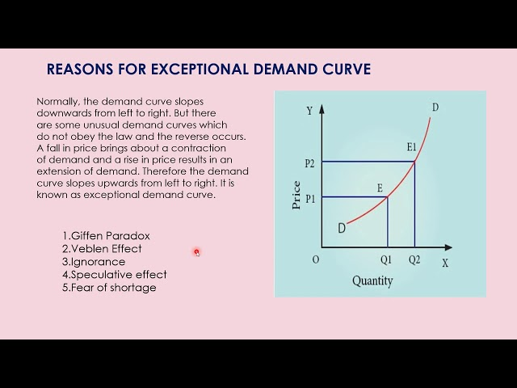

**Market Demand**

Market demand refers to the total quantity of a good or service that all consumers in the market are willing and able to purchase at various prices during a specific period.

It represents the aggregate of individual demands from all consumers in the market and is influenced by factors such as price, consumer income, preferences, and the prices of related goods.

Market demand is typically represented graphically as a demand curve, which shows the relationship between the price of the product and the quantity demanded by consumers, holding other factors constant.

Market demand provides insights into the overall behavior of consumers in the market and helps businesses and policymakers understand patterns of consumption and make decisions about pricing, production, and marketing strategies.

In summary, exceptional demand refers to temporary and extraordinary increases in the demand for specific goods or services, often driven by unique circumstances, while market demand represents the aggregate demand from all consumers in the market over a given period, reflecting the typical factors influencing consumption behavior.

**1.2.1.4 Individual Demand versus Market Demand**

Individual demand and market demand are two concepts used in economics to analyze the demand for goods and services:

**Individual Demand**

Individual demand refers to the quantity of a good or service that a single consumer is willing and able to purchase at various prices during a specific period.

It represents the demand curve for a particular consumer, showing how the quantity demanded changes in response to changes in price, assuming other factors remain constant.

Individual demand is influenced by factors such as the consumer's preferences, income, prices of related goods, and personal characteristics.

Each consumer in the market will have their own individual demand curve reflecting their unique preferences and circumstances.

**Market Demand**

Market demand refers to the total quantity of a good or service that all consumers in the market are willing and able to purchase at various prices during a specific period.

It represents the aggregate of individual demands from all consumers in the market, summing up the quantities demanded by each individual at different price levels.

Market demand is typically represented graphically as the horizontal summation of individual demand curves, showing the total quantity demanded at each price level in the market.

Market demand is influenced by factors affecting individual demand as well as factors such as population size, demographics, and market conditions.

In summary, individual demand focuses on the preferences and behavior of a single consumer, showing how their demand for a product changes with price, while market demand looks at the total demand from all consumers in the market, reflecting the aggregate behavior of consumers and providing insights into overall market behavior and trends.

**1.2.1.5 Factors Influencing Demand**

Several factors influence the demand for goods and services in an economy. Understanding these factors is essential for businesses, policymakers, and economists to predict consumer behavior and make informed decisions. Here are some of the key factors influencing demand:

Price of the Product: The most fundamental factor influencing demand is the price of the product itself. According to the law of demand, there is an inverse relationship between the price of a product and the quantity demanded, ceteris paribus. As the price of a product increases, the quantity demanded decreases, and vice versa.

Consumer Income: Consumer income is another significant determinant of demand. Generally, as consumers' income increases, their purchasing power increases, leading to higher demand for most goods and services, especially normal goods. Conversely, a decrease in income may lead to a decrease in demand, particularly for luxury goods.

Prices of Related Goods: The prices of related goods also influence demand. There are two types of related goods:

Substitute Goods: Goods that can be used as alternatives to each other. An increase in the price of one substitute good typically leads to an increase in demand for the other.

Complementary Goods: Goods that are consumed together. An increase in the price of one complementary good typically leads to a decrease in demand for the other.

Consumer Preferences and Tastes: Consumer preferences and tastes play a crucial role in determining demand. Changes in fashion trends, cultural influences, advertising, and marketing campaigns can all affect consumer preferences and, consequently, demand for certain products.

Expectations: Consumer expectations about future prices, income levels, and economic conditions can influence their current purchasing decisions. For example, if consumers expect the price of a product to increase in the future, they may increase their current demand to take advantage of lower prices.

Population and Demographics: Changes in population size, age distribution, and demographic factors such as household size, ethnicity, and geographic location can influence demand patterns. For instance, an aging population may lead to increased demand for healthcare services and retirement products.

Government Policies and Regulations: Government policies, such as taxation, subsidies, trade restrictions, and regulations, can impact demand for certain goods and services. For example, subsidies for electric vehicles may increase demand for them, while taxes on tobacco products may decrease demand for cigarettes.

Seasonal Factors and Weather Conditions: Seasonal factors and weather conditions can also influence demand for certain products. For instance, demand for winter clothing increases during colder months, while demand for ice cream rises during hot summer days.

By considering these factors, businesses can better understand consumer behavior and tailor their marketing strategies and pricing decisions accordingly. Similarly, policymakers can use this knowledge to design effective economic policies aimed at influencing aggregate demand and promoting economic stability and growth.

**1.2.1.6 Types of Demand**

Demand can be categorized into several types based on different criteria. Here are some common types of demand:

Individual Demand: Individual demand refers to the quantity of a good or service that a single consumer is willing and able to purchase at various prices during a specific period. It represents the demand curve for a particular consumer, showing how the quantity demanded changes in response to changes in price, assuming other factors remain constant.

Market Demand: Market demand refers to the total quantity of a good or service that all consumers in the market are willing and able to purchase at various prices during a specific period. It represents the aggregate of individual demands from all consumers in the market, summing up the quantities demanded by each individual at different price levels.

Derived Demand: Derived demand refers to the demand for a good or service that arises from the demand for another good or service. It occurs when the demand for one product is dependent on the demand for another product that it helps produce or complement. For example, the demand for steel is derived from the demand for automobiles and construction.

Effective Demand: Effective demand refers to the quantity of a good or service that consumers are both willing and able to buy at a given price level. It takes into account consumers' purchasing power, which depends on their income levels, credit availability, and other factors.

Composite Demand: Composite demand refers to the demand for a good or service that serves multiple purposes or has multiple uses. The same product can be demanded for different purposes by different consumers. For example, wheat can be demanded for making bread, animal feed, or ethanol production.

Joint Demand: Joint demand refers to the demand for two or more goods that are used together or complement each other. The demand for one product creates demand for the other products as well. For example, the demand for cars creates joint demand for gasoline, tires, and maintenance services.

Speculative Demand: Speculative demand refers to the demand for a good or service based on expectations of future price changes. Consumers may buy or hold assets with the expectation that their prices will increase in the future, allowing them to sell at a higher price and make a profit.

Understanding these different types of demand helps economists, businesses, and policymakers analyze consumer behavior, predict market trends, and make informed decisions about pricing, production, and marketing strategies.

**1.2.1.7 Movement along and Shifts of Demand Curves**

**Movement of the Demand Curve**

When there is a change in the quantity demanded of a particular [commodity](https://www.toppr.com/guides/economics/non-competitive-market/simple-monopoly-and-commodity-market/), because of a change in [price](https://www.toppr.com/guides/business-economics/determination-of-prices/intro-to-determination-of-prices/), with other factors remaining constant, there is a movement of the quantity demanded along the same [curve](https://www.toppr.com/guides/maths/basic-geometrical-ideas/curves/). The important aspect to remember is that other factors like the consumer’s income and tastes along with the prices of other goods, etc. remain constant and only the price of the commodity changes.In such a scenario, the change in price affects the quantity demanded but the demand follows the same curve as before the price changes. This is Movement of the Demand Curve. The movement can occur either in an upward or downward [direction](https://www.toppr.com/guides/reasoning-ability/data-sufficiency/direction-sense-test/) along the demand curve. We know that if all other factors remain constant, then an increase in the price of a commodity decreases its demand. Also, a decrease in the price increases the [demand](https://www.toppr.com/guides/business-economics/theory-of-demand/meaning-and-determinants-of-demand/). So, what happens to the demand curve?

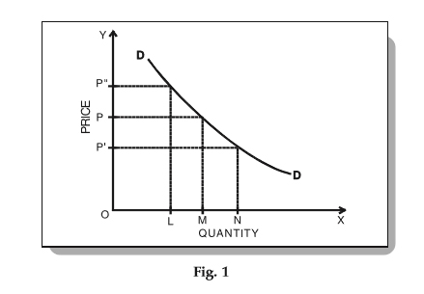

In Fig. 1 above, we can see that when the price of a commodity is OP, its demand is OM (provided other factors are constant). Now, let’s look at the effect of an increase and decrease in price on the demand:

When the price increases from OP to OP”, the quantity demanded falls to OL. Also, the demand curve moves UPWARD.

When the price decreases from OP to OP’, the quantity demanded rises to ON. Also, the demand curve moves DOWNWARD.

Therefore, we can see that a change in price, with other factors remaining constant moves the demand curve either up or down.

**Shifts of the Demand Curve**

When there is a change in the quantity demanded of a particular commodity, at each possible price, due to a change in one or more other factors, the demand curve [shifts](https://www.toppr.com/guides/economics/market-equilibrium/shifts-in-demand-and-supply/). The important aspect to remember is that other factors like the consumer’s income and tastes along with the prices of other goods, etc., which were expected to remain constant, changed.

In such a scenario, the change in price, along with a change in one/more other factors, affects the [quantity demanded](https://www.toppr.com/guides/fundamentals-of-economics-and-management/equilibrium/change-in-equilibrium-price-due-to-shift-in-demand/). Therefore, the demand follows a different curve for every price change.

This is the Shift of the Demand Curve. The demand curve can shift either to the left or the right, depending on the factors affecting it.

Let’s look at an example which captures the effect of a change in consumer’s income on the quantity demanded.

|  |  |  |
| --- | --- | --- |
| Price (Rs.) | Quantity demanded when the average household income is Rs. 4000 | Quantity demanded when the average household income is Rs. 5000 |
| 5 | 10 (A) | 15 (A1) |
| 4 | 15 (B) | 20 (B1) |
| 3 | 20 (C) | 25 (C1) |
| 2 | 35 (D) | 40 (D1) |
| 1 | 60 (E) | 65 (E1) |

The demanded quantities are plotted as demand curves DD and D’D’ as shown below:

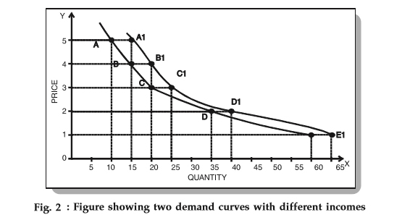

From Fig. 2 above, we can clearly see that if the income changes, then a change in price shifts the demand curve. In this case, the shift is to the right which indicates that there is an increase in the desire to purchase the commodity at all prices.

Hence, we can conclude that with an increase in income the demand curve shifts to the right. On the other hand, if the income falls, then the demand curve will shift to the left decreasing the desire to purchase the commodity.

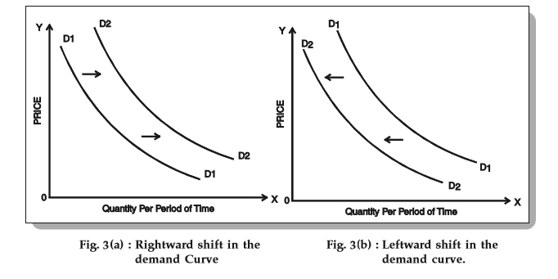

**1.2.1.8 Elasticity of Demand**

Elasticity of demand measures how responsive the quantity demanded of a good or service is to changes in price. It's calculated as the percentage change in quantity demanded divided by the percentage change in price. If the elasticity of demand is greater than 1, demand is considered elastic, meaning that changes in price lead to proportionally larger changes in quantity demanded. Conversely, if the elasticity is less than 1, demand is inelastic, indicating that changes in price result in smaller changes in quantity demanded.

**1.2.1.9 Types of Elasticity: Price, Income and Cross Elasticity**

**Price Elasticity of Demand (PED)**

Both the demand and supply curve show the relationship between price and the number of units demanded or supplied.  The **price elasticity of demand** is the percentage change in the quantity *demanded* of a good or service divided by the percentage change in the price. The **price elasticity of supply** is the percentage change in quantity *supplied* divided by the percentage change in price.

We can usefully divide elasticities into three broad categories: elastic, inelastic, and unitary. An **elastic demand** or **elastic supply** is one in which the elasticity is greater than one, indicating a high responsiveness to changes in price. Elasticities that are less than one indicate low responsiveness to price changes and correspond to**inelastic demand** or **inelastic supply**. **Unitary elasticities** indicate proportional responsiveness of either demand or supply.

Price elasticity of demand = Percentage change in price / percentage change in the quantity demanded

**Cross Elasticity**

A change in the price of one good can shift the quantity demanded for another good. If the two goods are complements, like bread and peanut butter, then a drop in the price of one good will lead to an increase in the quantity demanded of the other good. However, if the two goods are substitutes, like plane tickets and train tickets, then a drop in the price of one good will cause people to substitute toward that good, and to reduce consumption of the other good. Cheaper plane tickets lead to fewer train tickets, and vice versa. The **cross-price elasticity of demand** puts some meat on the bones of these ideas. The term “cross-price” refers to the idea that the price of one good is affecting the quantity demanded of a different good. Specifically, the cross-price elasticity of demand is the percentage change in the quantity of good A that is demanded as a result of a percentage change in the price of good B.

Cross elasticity of demand = Percentage change in quantity demanded of good A / percentage change in the price of good B

**1.2.1.10 Measurement of Elasticity: Point and Arc Elasticity**

**Point Elasticity**

Geometric measurement of price elasticity is possible through a method called the point elasticity method. **It measures the demand at any point of the curve when the demand curve is linear**. As per this method, the price elasticity of demand of various points on the demand curve shall be different. In geometry, the term ‘point’ refers to something that occupies no space and dimensions.

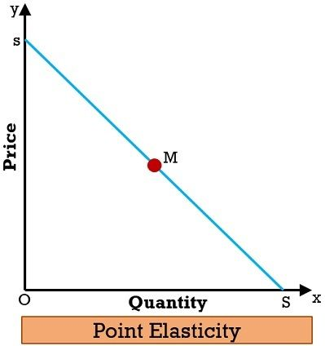

Practically, point elasticity is a measure of proportionate change in quantity demanded as a result of a very small proportionate change in the price. This concept is important when the change in price and the resultant change in demand is infinitesimally small.

Price elasticity of demand using point method = lower segment of the demand curve from that point / Upper segment of the demand curve from that point

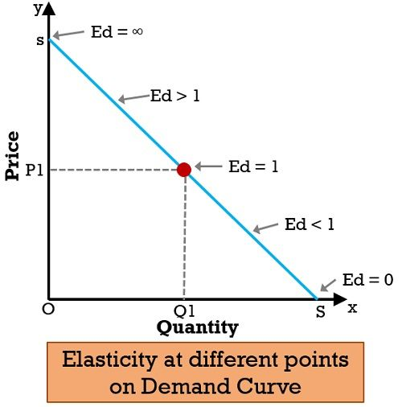

With the above graph we have understood that at the mid-point on the linear demand curve, elasticity equals**unity**. However, at the higher points on the same curve, i.e. to the left of the mid-point, elasticity will be **greater than unity**. Whilst, at lower points on the same curve, i.e. to the right of the midpoint, elasticity will be **less than unity**.

One must note that, at the corner point, i.e. end of the segment, elasticity equals **zero**. And, at the top, i.e. at the beginning of the segment, elasticity equals**infinity**.

**Arc Elasticity**

Have you ever wondered, how can we measure elasticity between two points on the same demand curve? So, we could do this through arc elasticity. For this, one has to calculate the averages of initial and final figures of price and quantity demanded. Arc elasticity is the elasticity of a variable in relation to another between two sets of points. This is used in the absence of any general function to define the relationship between two variables. We use this concept in two domains, i.e. mathematics and economics.

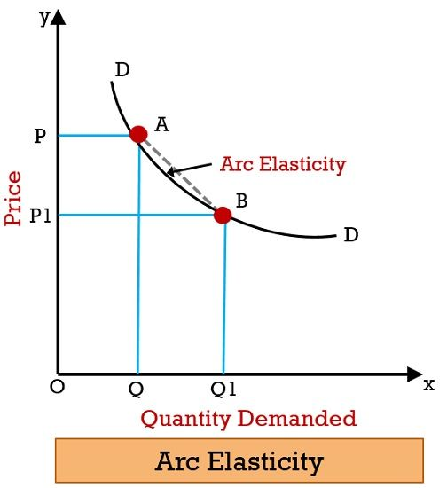

Further, we use arc elasticity to determine price elasticity over some part of the demand curve, instead of a single point. In finer terms, with the help of the arc method, we can compute elasticity over a range of prices.

Arc price elasticity of demand tends to measure the responsiveness of the quantity demanded in relation to the price of the product.

Points to Note

* We measure the elasticity over the arc of the demand curve on a graph.
* It calculates the elasticity using the central point in between two points.
* It is used when there is a substantial change in price. Also, it conveys the same elasticity outcome, even if the price decreases or increases.

Formula for Price Elasticity

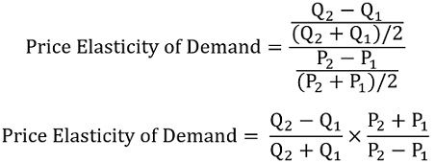

**Key Differences Between Point and Arc Elasticity**

In the points given below, you will find the differences between point and arc elasticity:

* Price Elasticity of Demand at a certain point on the demand curve is the point elasticity of demand. In contrast, Arc Elasticity refers to the elasticity amidst two points on the curve.
* Marshall introduced the concept of point elasticity in the year 1890. Whereas Dalton coined the concept of arc elasticity in 1920.
* The arc elasticity will always fall somewhere between pair of point elasticities, calculated at lower and higher prices. Whereas Point Elasticity is the elasticity at a finite point on the curve.
* In point elasticity, we make use of derivatives in place of finite changes in price and quantity. While in arc elasticity, we use a difference quotient.
* The percentage formula applies only in point elasticity. However, when there are finite changes in price and quantity demanded is such that it relates to a extend over the demand curve, then the percentage formula is modified is arc elasticity.
* The point elasticity method of measuring elasticity is used in case the changes in price and quantity demanded are immeasurably small. This is for the reason that such a minute change indicates a virtual point on the demand curve. As against, if there are considerable changes we use the arc elasticity method. This is because we are taking a discrete movement along an arc of the demand curve.

**1.2.1.11 Factors Influencing Elasticity Demand**

Several factors influence the elasticity of demand for a particular good or service:

Availability of Substitutes: The availability of substitutes is a significant factor in determining elasticity. If close substitutes are readily available, consumers can easily switch to alternatives when prices change, making demand more elastic. Conversely, if there are few or no substitutes, demand tends to be inelastic because consumers have fewer options to switch to.

Necessity vs. Luxury: Goods that are considered necessities often have inelastic demand because consumers need them regardless of price changes (e.g., basic food items, medications). Luxury goods, on the other hand, tend to have more elastic demand because consumers can easily forego or substitute them when prices increase.

Proportion of Income Spent: The proportion of income that consumers spend on a particular good affects its elasticity. Goods that represent a small portion of consumers' budgets typically have inelastic demand because consumers are less sensitive to price changes for these items. Conversely, goods that represent a significant portion of income tend to have more elastic demand.

Time Horizon: The elasticity of demand can vary over different time horizons. In the short run, demand for many goods may be relatively inelastic because consumers cannot easily adjust their consumption patterns. However, in the long run, consumers have more time to adjust their behavior, making demand more elastic.

Brand Loyalty: Strong brand loyalty can make demand for a particular product less elastic because consumers are less likely to switch to alternatives, even if prices increase. Brands with loyal customer bases can maintain higher prices without significant declines in demand.

Perceived Necessity: Goods that are perceived as essential or have unique features that differentiate them from substitutes may have less elastic demand. Consumers may be willing to pay higher prices for these goods due to their perceived value or necessity.

Habitual Consumption: Goods that are habitually consumed or have addictive properties may have inelastic demand because consumers continue to purchase them regardless of price changes. Examples include cigarettes, alcohol, and certain types of fast food.

Understanding these factors is essential for businesses when making pricing decisions and for policymakers when implementing taxation policies or regulations. They help predict how changes in price or income will affect the quantity demanded of a particular good or service.

**1.2.1.12 Application of Elasticity of Demand**

The concept of elasticity of demand finds numerous applications across various fields, including business, economics, and public policy. Here are some key applications:

Pricing Strategy: Businesses use elasticity of demand to set optimal prices for their products. Understanding demand elasticity helps companies determine whether they should increase or decrease prices and by how much. For example, if demand for a product is elastic, a price decrease may lead to a significant increase in revenue due to the larger increase in quantity demanded.

Revenue Management: Elasticity of demand is crucial in revenue management strategies, such as dynamic pricing. Companies in industries like airlines, hotels, and entertainment adjust prices based on demand elasticity to maximize revenue. For instance, airlines may lower prices during off-peak times to stimulate demand from price-sensitive customers.

Product Development: Elasticity of demand can inform product development decisions by helping companies identify market opportunities. Products with elastic demand may indicate opportunities for innovation and differentiation to capture a larger market share. Conversely, products with inelastic demand may suggest opportunities for cost optimization and efficiency improvements.

Taxation Policy: Governments use elasticity of demand to design effective taxation policies. Goods with inelastic demand, such as tobacco and gasoline, are often targeted for higher taxes as consumers are less likely to reduce consumption in response to price increases. This can help generate revenue and discourage the consumption of goods with negative externalities.

Public Services Provision: Elasticity of demand is relevant in determining the pricing and allocation of public services, such as healthcare and education. Understanding demand elasticity helps policymakers assess the impact of pricing policies on access and affordability. For example, subsidies may be provided for essential services with inelastic demand to ensure accessibility for low-income individuals.

Advertising and Promotion: Elasticity of demand influences advertising and promotional strategies. Products with elastic demand may benefit from advertising campaigns focused on price discounts and promotions to stimulate demand. In contrast, products with inelastic demand may prioritize advertising messages highlighting product quality, features, or benefits.

Investment Analysis: Investors use elasticity of demand to evaluate the attractiveness of investment opportunities in various industries. Industries with products or services exhibiting elastic demand may be considered more volatile but potentially offer higher returns during economic upswings. Conversely, industries with products or services displaying inelastic demand may provide more stable returns but with lower growth potential.

In summary, elasticity of demand is a versatile concept that informs decision-making across different sectors, helping businesses optimize pricing strategies, governments design effective policies, and investors assess market opportunities.

**Supply Analysis**

**1.2.2.1 Definition**

Supply refers to the quantity of goods or services that producers are willing and able to offer for sale at various prices during a specified period. It represents the relationship between the price of a good or service and the quantity that producers are willing to produce and sell in the market.

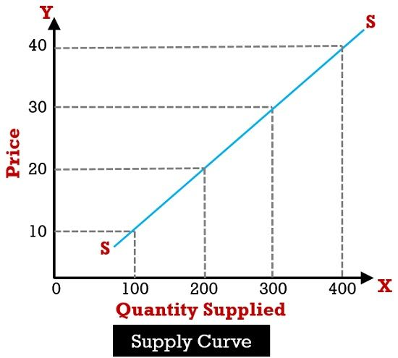

**1.2.2.2 Individual vs Market Supply**

Individual supply and market supply are two concepts that help understand the supply of goods and services within an economy:

Individual Supply: Individual supply refers to the quantity of a good or service that a single producer or firm is willing and able to offer for sale at various prices during a specified period. It represents the behavior of a specific producer in response to changes in price. Individual supply is influenced by factors such as production costs, technology, resource availability, and the goals and objectives of the individual producer.

Market Supply: Market supply, on the other hand, refers to the total quantity of a good or service that all producers in a market are collectively willing and able to offer for sale at various prices during a specified period. It represents the aggregate behavior of all producers in the market. Market supply is determined by summing up the individual supplies of all producers operating in the market.

While individual supply focuses on the actions of a single producer, market supply considers the combined behavior of all producers within a particular market. The relationship between individual supply and market supply is similar to that between individual demand and market demand: individual quantities are aggregated to derive market quantities.

Understanding both individual and market supply is crucial for analyzing supply dynamics in markets, assessing the impact of changes in factors affecting supply, and making informed decisions related to production, pricing, and resource allocation.

**1.2.2.3 Factors Influencing Supply**

Several factors influence the supply of goods and services in economics:

Production Costs: Production costs, including labor, raw materials, equipment, and energy costs, play a significant role in determining supply. Higher production costs typically lead to lower supply, as producers may be less willing or able to produce goods at higher costs.

Technology: Technological advancements can increase productivity and efficiency in production, leading to higher supply. Improved technology often allows producers to lower their costs of production, enabling them to supply more goods at lower prices.

Resource Prices: The prices of inputs such as labor, land, and capital equipment impact production costs and, consequently, supply. Changes in resource prices can affect the profitability of production and influence the quantity of goods producers are willing to supply.

Government Policies: Government regulations, taxes, subsidies, and trade policies can affect the cost of production and the ease of doing business, thereby influencing supply. For example, subsidies to producers can increase supply by reducing their production costs, while taxes or regulations may decrease supply by increasing costs or restricting production.

Expectations: Producer expectations about future market conditions, including prices, demand, and input costs, can influence current supply decisions. If producers anticipate higher future prices, they may decrease current supply to take advantage of potential future profits, and vice versa.

Number of Producers: The number of firms or producers operating in a market can affect supply. An increase in the number of producers can lead to an increase in market supply as more firms compete to sell goods, while a decrease in the number of producers may reduce supply.

Natural Factors: Natural events such as weather conditions, natural disasters, and diseases can affect the supply of agricultural and natural resource-based goods. For example, adverse weather conditions can reduce crop yields, leading to lower agricultural supply.

Prices of Related Goods: The prices of related goods, including substitutes and complements, can influence supply. Higher prices of substitutes may lead producers to allocate more resources to the production of the substitute good, reducing supply in the original market. Conversely, higher prices of complements may increase supply if the production of one good relies on the production of another.

These factors interact to determine the quantity of goods and services that producers are willing and able to supply at various prices. Understanding these influences on supply is essential for analyzing market dynamics, forecasting future supply trends, and formulating effective economic policies.

**1.2.2.4 Movements Along and Shifts of the Supply Curve**

Movement along the supply curve or change in quantity supplied refers to extension and contraction of supply of a commodity caused by change in own price of the commodity. When price increases, there is an upward movement (a→b) along the supply curve, called extension of supply; and when price decreases, there is a downward movement (b→a) along the supply curve, called contraction of supply. See below:

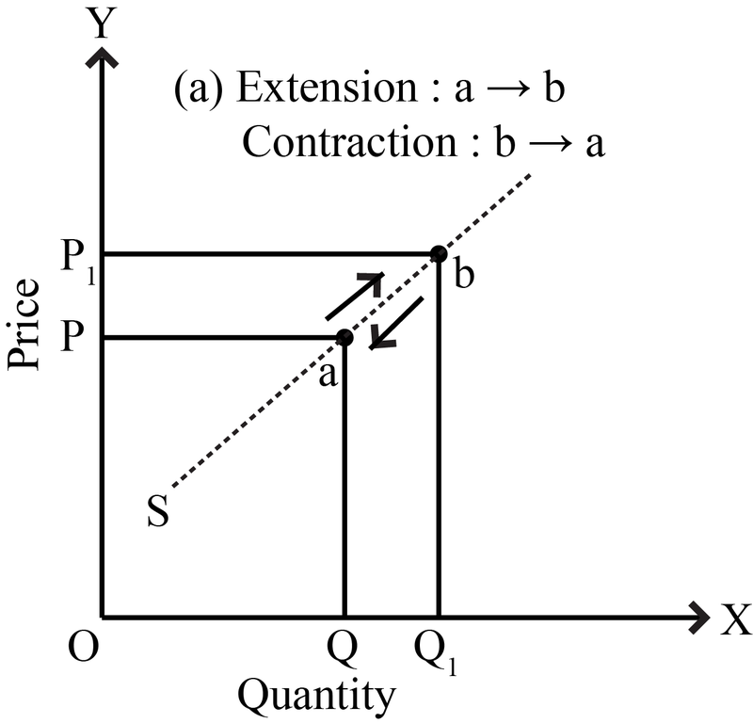

Shift of supply curve or change in supply refers to increase or decrease in supply of a commodity caused by change in factors other than own price of the commodity. When other factors change in the favourable direction, the supply curve shifts to the right showing increase in supply; and when other factors change in an unfavourable manner, the supply curve shifts to the left showing a decrease in supply. See below:

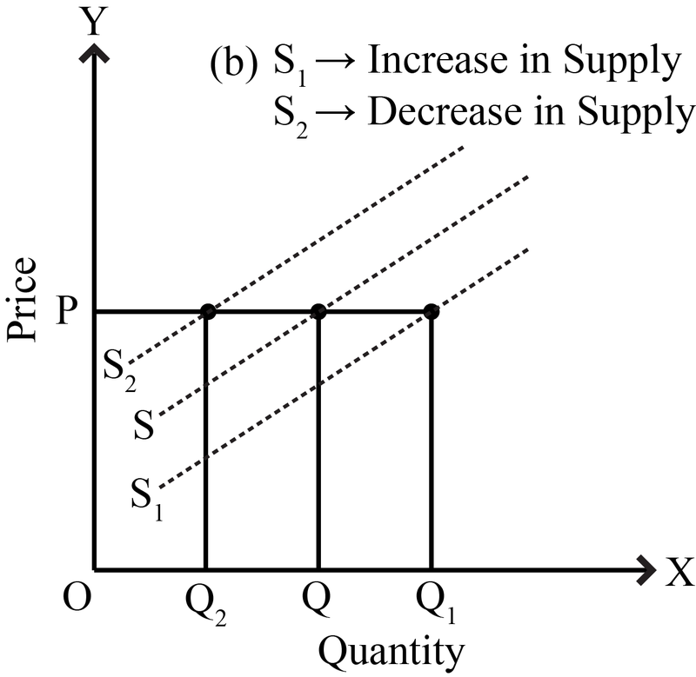

**1.2.2.5 Definition of Elasticity of Supply**

Elasticity of supply measures the responsiveness of the quantity supplied of a good or service to changes in its price. It indicates how much the quantity supplied changes in response to a change in price.

**1.2.2.6 Price Elasticity of Supply**

Mathematically, the elasticity of supply (ES) = Percentage Change in Quantity Supplied / Percentage Change in Price

Similar to the concept of elasticity of demand, the elasticity of supply can be classified into three main categories:

Elastic Supply: If the percentage change in quantity supplied is greater than the percentage change in price (ES > 1), supply is considered elastic. In elastic supply, producers can adjust their production levels significantly in response to changes in price. This may occur in industries with excess capacity or where production inputs are readily available.

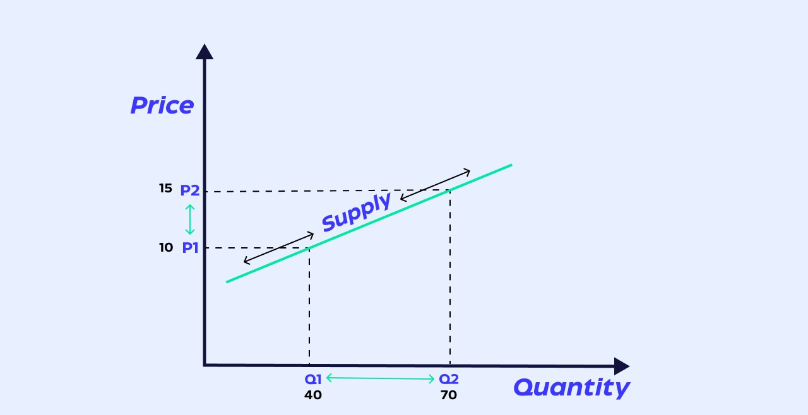

Inelastic Supply: If the percentage change in quantity supplied is less than the percentage change in price (ES < 1), supply is considered inelastic. In this case, producers are unable to adjust their production levels easily in response to changes in price. This may occur in industries where production capacity is constrained or where inputs are scarce.

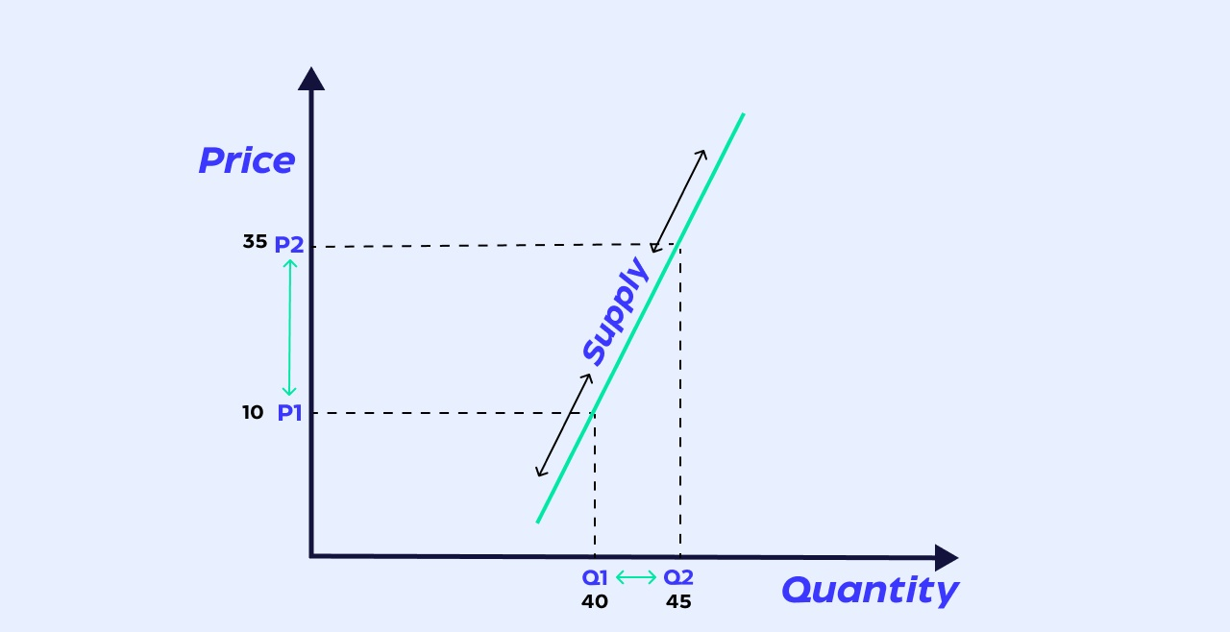

Unitary Elastic Supply: If the percentage change in quantity supplied is equal to the percentage change in price (ES = 1), supply is considered unitary elastic. In unitary elastic supply, the percentage change in quantity supplied is exactly proportional to the percentage change in price.

Factors influencing the elasticity of supply include the availability of production inputs, production technology, time horizon, and the mobility of resources. In general, the elasticity of supply tends to be more elastic in the long run as producers have more time to adjust production levels and invest in additional capacity.

Understanding the elasticity of supply is important for businesses, policymakers, and economists in predicting how changes in price will affect the quantity supplied of goods and services, as well as in making decisions related to production, pricing, and resource allocation.

**1.2.2.7 Factors Influencing Elasticity of Supply**

Several factors influence the elasticity of supply, affecting how responsive producers are to changes in price. Here are some key factors:

Availability of Inputs: The availability and ease of obtaining production inputs, such as raw materials, labor, and capital, can significantly impact the elasticity of supply. If inputs are readily available and easily accessible, producers can quickly increase or decrease production in response to price changes, resulting in a more elastic supply.

Time Horizon: The time frame under consideration can influence the elasticity of supply. In the short run, production capacity and resources may be fixed, limiting the ability of producers to adjust output in response to price changes, leading to inelastic supply. In the long run, producers have more flexibility to adjust production levels, invest in new technology, and expand capacity, making supply more elastic.

Production Flexibility: The degree to which production processes can be adjusted or altered in response to changes in price affects elasticity of supply. Industries with flexible production processes and easily adaptable technology tend to have more elastic supply curves, as producers can quickly respond to price changes by adjusting output levels.

Substitutability of Inputs: The ease with which producers can substitute one input for another in the production process influences supply elasticity. If inputs are highly substitutable, producers can easily switch between inputs in response to price changes, resulting in a more elastic supply. Conversely, if inputs are specialized or unique, supply may be more inelastic.

Storage Capacity: The ability to store goods and inventory levels can affect the elasticity of supply. Producers with ample storage capacity can store excess inventory during periods of low demand and release it when prices rise, leading to a more elastic supply response.

Market Structure: The structure of the market, including the number of producers and the level of competition, can influence the elasticity of supply. In highly competitive markets with many producers, supply tends to be more elastic as firms compete to increase market share. In contrast, in monopolistic or oligopolistic markets with few producers, supply may be less elastic due to limited competition.

Government Regulations: Government policies, regulations, and taxes can impact the elasticity of supply by affecting production costs, market entry and exit barriers, and overall business conditions. Policies that increase production costs or impose restrictions on production can reduce supply elasticity, while policies that promote competition and innovation can enhance supply elasticity.

**1.2.2.8 Applications of Elasticity of Supply**

The elasticity of supply has various practical applications across different sectors of the economy:

Business Decision Making: Understanding the elasticity of supply helps businesses make informed decisions about production levels, pricing strategies, and resource allocation. For example, if supply is elastic, businesses may adjust production quickly in response to changes in demand or price, optimizing their operations to maximize profits.

Inventory Management: Elasticity of supply influences inventory management decisions. Businesses with elastic supply may maintain lower inventory levels, as they can quickly ramp up production to meet increased demand. In contrast, businesses with inelastic supply may need to maintain higher inventory levels to ensure supply stability during periods of fluctuating demand or supply disruptions.

Supply Chain Management: Supply chain managers use elasticity of supply to optimize supply chain operations and mitigate risks. By understanding supply elasticity, managers can identify potential bottlenecks, assess suppliers' responsiveness to changes in demand or price, and develop strategies to improve supply chain efficiency.

Government Policy: Policymakers use elasticity of supply to design and evaluate economic policies. For example, policymakers may assess the impact of taxes, subsidies, or regulations on supply elasticity to predict how producers will respond to changes in policy and to minimize unintended consequences.

Infrastructure Planning: Infrastructure planners use elasticity of supply to inform infrastructure investment decisions. By understanding supply elasticity, planners can anticipate future demand for infrastructure services, such as transportation, energy, or telecommunications, and allocate resources effectively to meet growing demand.

Resource Management: Elasticity of supply informs resource management decisions in industries such as agriculture, mining, and energy. For example, in agriculture, farmers may adjust crop planting decisions based on the elasticity of supply for different crops, considering factors such as input costs, weather conditions, and market prices.

Market Analysis: Market analysts use elasticity of supply to assess market dynamics and forecast future supply trends. By analyzing supply elasticity, analysts can identify factors influencing supply responsiveness, such as technological advancements, input prices, and production constraints, and anticipate their impact on market equilibrium.

International Trade: Elasticity of supply influences trade decisions and trade policy formulation. Countries with elastic supply may be more responsive to changes in international demand or price, making them competitive exporters in global markets. In contrast, countries with inelastic supply may face challenges in adjusting production levels to meet export demand or respond to changes in trade policies.

**1.2.3 Determination of Equilibrium**

**1.2.3.1 Interaction of Supply and Demand. Equilibrium Price and Quantity**

The interaction of supply and demand is a fundamental concept in economics that determines the equilibrium price and quantity in a market. It occurs where the supply curve intersects with the demand curve, representing the point at which the quantity demanded by consumers equals the quantity supplied by producers.

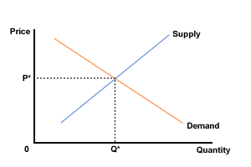

On a graph, the point where the supply curve (S) and the demand curve (D) intersect is the equilibrium. The equilibrium price is the only price where the desires of consumers and the desires of producers agree—that is, where the amount of the product that consumers want to buy (quantity demanded) is equal to the amount producers want to sell (quantity supplied). This mutually desired amount is called the equilibrium quantity. At any other price, the quantity demanded does not equal the quantity supplied, so the market is not in equilibrium at that price. It should be clear, from the previous discussions of surpluses and shortages, that if a market is not in equilibrium, then market forces will push the market to the equilibrium.

**1.2.3.2 Mathematical Approach to Equilibrium**

It is possible to mathematically calculate the equilibrium price of a product, assuming the quantity of the demanded product is equal to the quantity supplied. You can use linear algebraic equations to find the supply line and demand line of a product on a graph to see where they intersect. This point of intersection is the equilibrium price formula, which sets the supply function and demand function equal to each other. These three formulas look like this:

The linear supply function is:

Qs = x + yP

Where:

Qs = the quantity supplied

X = quantity

P = price

The linear demand function is:

Qd = x + yP

Where:

Qd = the quantity of demand

X = quantity

P = price

The equilibrium price sets the two equal to each other:

Qs = Qd

|  |
| --- |
| **Example of equilibrium price**  Here is an example of finding the equilibrium price for organic pineapples sold at a fruit stand:  The fruit stand was selling 500 pineapples for $4.00 each every month but wants to begin selling 900 pineapples for $3.00 each every month. With this information, the fruit stand can calculate whether the new supply and demand quantities are at the equilibrium price.  Here, we take the quantity of supplied pineapples and the price of those pineapples and put them into the equation.  Qs = 500 + 4P  Next, we use the number of demanded pineapples and the price at which the fruit stand is considering selling them.  Qd = 900 + 3P  Set the two quantities equal in terms of price:  Qs = Qd  500 + 4P = 900 + 3P  Take the equation above and simplify it:  500 + 4P = 900 + 3P  500 + 1P = 900  1P = 400  P = 400  P = $4.00  This means that the equilibrium price for the pineapples at the fruit stand is $4.00. If the fruit stand lowers the price below $4.00, an excess in demand would cause the buyers to want more pineapples than the fruit stand can sell.  If the fruit stand raises the price above $4.00, an excess in supply would cause buyers to want fewer pineapples than the fruit stand can sell. If the fruit stand keeps the price of their pineapples at $4.00, then there is a balance between supply and demand, which is good for both the buyers and the fruit stand. |

**1.2.3.3 Stable vs Unstable Equilibrium**

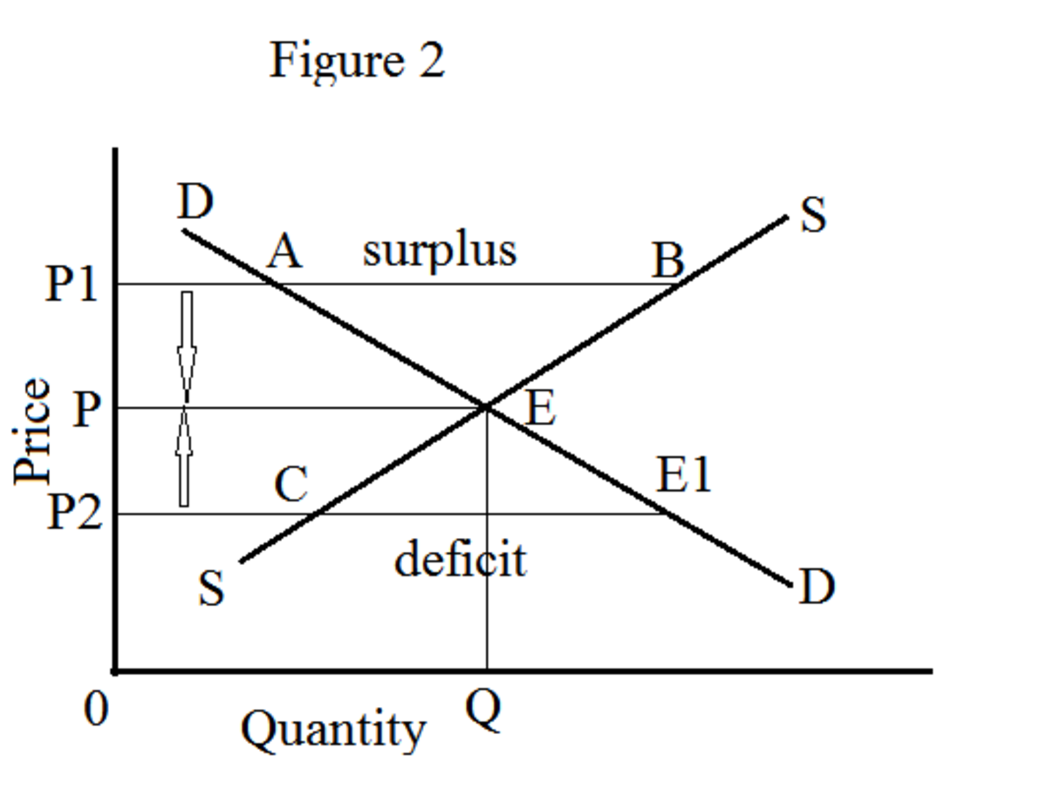

In the figure above, DD represents a negatively sloped demand curve, and SS denotes a positively sloped supply curve. The equilibrium occurs at point E. At this point, the supply and demand are in balance; the equilibrium price OP and the equilibrium quantity OQ are determined. It is a classic example of stable equilibrium in economics. Let us assume that the market price is OP1. At this price, P1B is the quantity supplied while the quantity demanded is only P1A. Hence, the quantity supplied is more than the quantity demanded. The surplus quantity in the market is to the extent of AB. This creates a downward pressure on price. The downward pressure applies until the price reaches the equilibrium level at which the quantity supplied equals the quantity demanded. In the diagram, let us consider the price OP2. At this price level, the quantity supplied is less than the quantity demanded. CE1 denotes the volume of commodity shortages. Due to this excess demand, an upward pressure on the price applies. This upward pressure pushes up the price to the equilibrium level at which the quantity supplied equals the quantity demanded.

**Unstable Equilibrium in Economics**

In supply and demand analysis, unstable equilibrium can occur at two occasions: (1) when there is a negatively sloped supply curve and (2) when there is a positively sloped demand curve.

1. Negatively Sloped Supply Curve

Unstable equilibrium occurs when there is a negatively sloped demand curve, which is normal, and a negatively sloped supply curve, which is a rare and exceptional case. This negatively sloping supply curve is possible when both increasing production and decreasing costs occur simultaneously due to various internal and external economies of scale enjoyed by the firm.

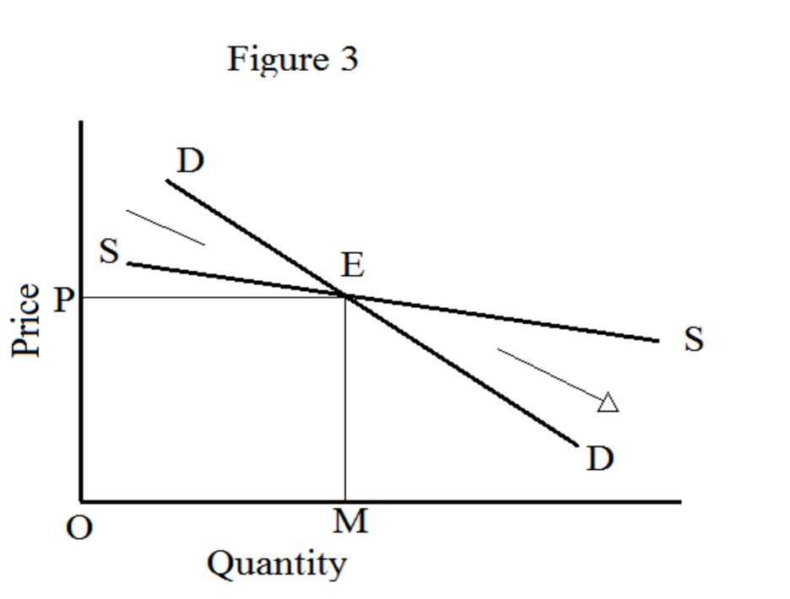

In the figureabove, the point E represents equilibrium. OP is the equilibrium price, and OM is the equilibrium quantity. If the price goes above the equilibrium price, the quantity demanded is more than the quantity supplied. Because of this excess demand, the price goes up further and moves away from equilibrium.

2. Positively Sloped Demand Curve

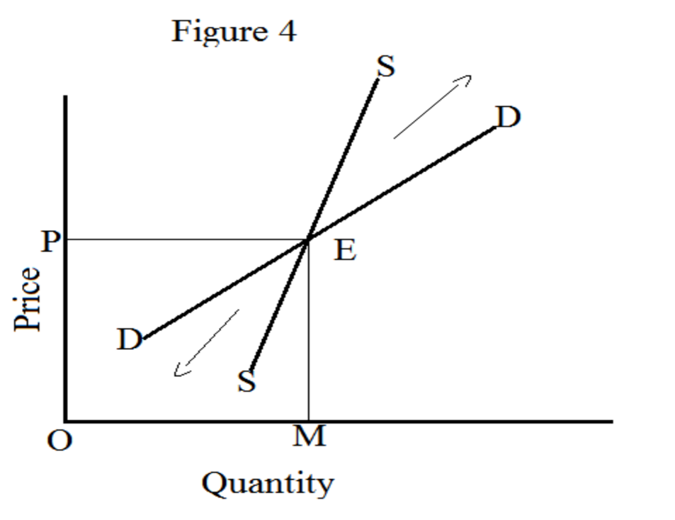

A second scenario of unstable equilibrium exists while the supply curve is usual and the demand curve is positively sloping. Such a demand curve is applicable in the event of ‘giffen goods’. In the instance of giffen goods, demand goes up while the price of the commodity rises and vice versa.

In Figure 4, the rare demand curve intersects the regular supply curve at E, which establishes the equilibrium price at OP and the equilibrium quantity at OM. A rise in price above OP causes an excessive amount of demand oversupply. This excess demand over supply provokes another great increase in the price. A reduction in price below OP contributes to excess supply over demand. This excess supply over demand triggers a further decrease in the price.

**1.2.3.4 Effects of Shifts in Demand and Supply on Market Equilibrium**

**When only Demand Changes**

A change in demand can be recorded as either an increase or a decrease. Note that in this case there is a shift in the demand curve.

**Increase in Demand**

When there is an increase in demand, with no change in supply, the demand curve tends to shift rightwards. As the demand increases, a condition of excess demand occurs at the old equilibrium price. This leads to an increase in competition among the buyers, which in turn pushes up the price.

**Decrease in Demand**

Under conditions of a decrease in demand, with no change in supply, the demand curve shifts towards left. When demand decreases, a condition of excess supply is built at the old equilibrium level. This leads to an increase in competition among the sellers to sell their produce, which obviously decreases the price.

Now as for price decreases, more consumers start demanding the good or service. Observably, this decrease in price leads to a fall in supply and a rise in demand. This counter mechanism continues until the conditions of excess supply are wiped out at the old equilibrium level and a new equilibrium is established. Effectively, there is a decrease in both the equilibrium price and quantity.

**1.2.3.5 Effects of Taxes and Subsidies on Market Equilibrium**

Taxes and subsidies are tools used by governments to influence market equilibrium by altering the supply and demand dynamics. Let's break down their effects:

**Taxes:**

On producers: When a tax is imposed on producers, the cost of production increases, leading to a decrease in the quantity supplied. This shift in the supply curve results in a new equilibrium with a higher price and lower quantity.

On consumers: When a tax is imposed on consumers, the price paid by consumers increases, leading to a decrease in quantity demanded. This shift in the demand curve results in a new equilibrium with a lower price and lower quantity.

The overall effect of a tax depends on the relative elasticities of demand and supply. If demand is more elastic than supply (consumers are more responsive to price changes than producers), consumers bear less of the burden of the tax. If supply is more elastic, producers bear more of the burden.

**Subsidies:**

To producers: When a subsidy is provided to producers, the cost of production decreases, leading to an increase in the quantity supplied. This shift in the supply curve results in a new equilibrium with a lower price and higher quantity.

To consumers: When a subsidy is provided to consumers, the price paid by consumers decreases, leading to an increase in quantity demanded. This shift in the demand curve results in a new equilibrium with a lower price and higher quantity.

Similar to taxes, the overall effect of a subsidy depends on the elasticities of demand and supply. If demand is more elastic than supply, consumers benefit more from the subsidy. If supply is more elastic, producers benefit more.

In summary, taxes tend to raise prices and reduce quantity, while subsidies tend to lower prices and increase quantity. Both can have redistributive effects and can be used to correct market failures or achieve specific policy goals, such as promoting certain industries, reducing negative externalities, or raising government revenue.

**1.2.3.6 Price Controls: Maximum and Minimum Price Control**

Price controls, whether in the form of maximum or minimum prices, are government regulations that directly dictate the price at which a good or service can be bought or sold. These controls can have significant effects on market equilibrium:

**Maximum Price Control (Price Ceiling):**

A maximum price control sets a legal limit on the price at which a good or service can be sold. This limit is typically set below the equilibrium price that would prevail in a free market.

Effects:

When the maximum price is set below the equilibrium price, it creates excess demand (shortage) because the quantity demanded exceeds the quantity supplied at that price.

Consumers benefit from lower prices, but producers may reduce their production or exit the market altogether due to reduced profitability.

Black markets may emerge as consumers are willing to pay more than the controlled price to obtain the limited supply.

Government may need to enforce the price ceiling to prevent price gouging and maintain public support for the policy.

**Minimum Price Control (Price Floor):**

A minimum price control sets a legal limit on the price at which a good or service can be sold, typically above the equilibrium price.

Effects:

When the minimum price is set above the equilibrium price, it creates excess supply (surplus) because the quantity supplied exceeds the quantity demanded at that price.

Producers benefit from higher prices, but consumers may reduce their purchases due to the increased cost.

Government may need to purchase surplus goods to support prices or implement other measures to reduce oversupply.

Minimum wage is a common example of a price floor in labor markets, where the minimum wage is set above the equilibrium wage to ensure workers receive a certain level of compensation.

In both cases, price controls can distort market outcomes, leading to inefficiencies such as misallocation of resources, reduced consumer surplus, and deadweight loss. The effectiveness of price controls depends on various factors, including the elasticity of demand and supply, market structure, and government enforcement mechanisms.

**1.2.3.7 Price Decontrol: Effect of Minimum and Maximum Price Decontrol**

Price decontrol, whether removing maximum or minimum price controls, has significant effects on market equilibrium. Let's examine both scenarios:

**Maximum Price Decontrol (Removing Price Ceilings):**

When maximum price controls are removed, allowing prices to rise to their natural equilibrium level:

Prices increase to reflect the equilibrium between supply and demand.

Quantity supplied increases as producers have the incentive to produce more at higher prices.

Excess demand (shortage) may initially occur if the previous controlled price was below the equilibrium price, but this shortage is resolved as prices rise to equilibrium.

Consumers who were previously benefiting from the lower prices may experience higher costs, potentially leading to decreased consumer surplus.

Producers may experience increased profitability, leading to greater investment and production in the long run.

The removal of price ceilings can eliminate distortions in the market, leading to a more efficient allocation of resources.

**Minimum Price Decontrol (Removing Price Floors):**

When minimum price controls are removed, allowing prices to fall to their natural equilibrium level:

Prices decrease to reflect the equilibrium between supply and demand.

Quantity demanded increases as consumers have the incentive to purchase more at lower prices.

Excess supply (surplus) may initially occur if the previous controlled price was above the equilibrium price, but this surplus is resolved as prices fall to equilibrium.

Producers who were previously benefiting from the higher prices may experience decreased revenue, potentially leading to reduced production or exit from the market.

Consumers benefit from lower prices, potentially leading to increased consumer surplus.

The removal of price floors can eliminate inefficiencies in the market, leading to a more efficient allocation of resources.

In both cases, the removal of price controls allows market forces of supply and demand to determine prices and quantities, leading to a more efficient allocation of resources. However, the short-term effects of decontrol may involve adjustments as the market transitions to the new equilibrium. Additionally, the impact on consumers and producers depends on their respective elasticities of demand and supply.

**1.2.3.8 Reasons for Price Fluctuations in Agriculture**

Price fluctuations in agriculture can be influenced by a variety of factors, both within the agricultural sector itself and external to it. Here are some common reasons:

Weather Conditions: Weather plays a significant role in agricultural production. Droughts, floods, storms, and other extreme weather events can damage crops, reduce yields, and disrupt supply chains, leading to price fluctuations.

Supply and Demand Dynamics: Changes in supply and demand can affect agricultural prices. For example, if there's a bumper crop one year, supply may exceed demand, causing prices to drop. Conversely, if demand outstrips supply due to population growth or changes in consumer preferences, prices may rise.

Government Policies: Government policies such as subsidies, tariffs, import/export regulations, and agricultural support programs can influence agricultural prices. For example, subsidies to farmers can increase production and lower prices, while tariffs on imports can protect domestic producers and raise prices.

Global Economic Factors: Economic conditions, including exchange rates, inflation, interest rates, and overall economic growth, can impact agricultural prices. For instance, a strong currency can make exports more expensive and reduce demand from overseas markets.

Technology and Innovation: Advances in technology, such as improved seeds, machinery, and farming techniques, can affect agricultural productivity and prices. Increased efficiency can lead to higher yields and lower production costs, which may influence prices.

Energy Prices: Agriculture is highly energy-intensive, relying on fuel for machinery, transportation, and fertilizer production. Fluctuations in energy prices, particularly those of oil and gas, can influence agricultural input costs and, consequently, prices.

Speculation and Financial Markets: Speculation in commodity markets by investors and financial institutions can lead to price volatility in agricultural commodities. Factors such as investor sentiment, market speculation, and macroeconomic trends can influence prices independently of supply and demand fundamentals.

Trade Policies and Trade Agreements: Trade policies and international trade agreements can impact agricultural prices by affecting market access, tariffs, and trade barriers. Changes in trade policies can open up new markets or restrict access to existing ones, influencing prices accordingly.

Pests and Diseases: Outbreaks of pests and diseases can devastate crops, leading to reduced yields and higher prices. Pest infestations or disease outbreaks can occur suddenly and unpredictably, causing supply shortages and price spikes.

Consumer Preferences and Dietary Trends: Changes in consumer preferences and dietary trends can affect demand for certain agricultural products. For example, increased demand for organic or plant-based foods can influence prices for organic produce or alternative protein sources.

These factors often interact in complex ways, contributing to the variability and unpredictability of agricultural prices. Additionally, regional differences in production, climate, and market conditions can further complicate price fluctuations within specific agricultural commodities.

**1.2.4 The Theory of Consumer Behaviour**

**1.2.4.1 Approaches to the Theory of the Consumer – Cardinal vs Ordinal Approach**

The theory of consumer behavior explores how individuals make decisions about what goods and services to purchase based on their preferences and budget constraints. Two primary approaches to this theory are the cardinal utility approach and the ordinal utility approach. Let's delve into each:

**Cardinal Utility Approach:**

Definition: In the cardinal utility approach, utility is measured numerically and treated as a quantifiable and measurable concept. This approach assumes that utility can be assigned specific units of measurement, such as utils.

Indifference Curves: Indifference curves represent combinations of goods that provide the consumer with equal levels of satisfaction or utility. These curves are typically drawn on a graph with axes representing different goods.

Assumption of Utility Maximization: According to this approach, consumers aim to maximize their total utility subject to their budget constraints. They allocate their income among different goods in such a way that the marginal utility per dollar spent is equal for all goods (the principle of equimarginal utility).

Ordinal Utility Approach:

Definition: In the ordinal utility approach, utility is ranked or ordered rather than measured quantitatively. It focuses on the preferences of consumers rather than attempting to quantify utility.

Preference Ordering: Consumers rank different bundles of goods based on their preferences. This approach is concerned with identifying which bundle of goods a consumer prefers to another but doesn't assign specific numerical values to utility.

Indifference Curves: While indifference curves are still used in the ordinal approach, they represent combinations of goods that provide the consumer with the same level of satisfaction, without assigning specific numerical values to utility.

Assumption of Transitivity: One of the key assumptions in the ordinal utility approach is the transitivity of preferences, meaning that if a consumer prefers bundle A to bundle B and bundle B to bundle C, then the consumer must prefer bundle A to bundle C.

**Comparison:**

Measurement of Utility: Cardinal utility approach measures utility quantitatively, whereas ordinal utility approach ranks utility without assigning specific numerical values.

Indifference Curves: Both approaches use indifference curves, but they serve different purposes. In the cardinal approach, indifference curves represent combinations of goods that yield equal levels of utility, while in the ordinal approach, they represent combinations that yield the same level of satisfaction, without quantifying utility.

Consumer Behavior: While both approaches analyze consumer behavior and preferences, they differ in how they conceptualize utility. The cardinal approach focuses on measuring utility directly, while the ordinal approach emphasizes preference rankings.

In modern economics, the ordinal utility approach is more commonly used because it avoids the measurement and aggregation issues associated with cardinal utility. It relies on revealed preference theory and choice under constraints to analyze consumer behavior without the need to quantify utility.

**1.2.4.2 Utility Analysis, Marginal Utility (MU), Law of Diminishing Marginal Utility**

Utility analysis in economics is a framework used to understand and analyze how individuals make choices regarding the consumption of goods and services. Utility refers to the satisfaction or pleasure that individuals derive from consuming goods and services. Here's a breakdown of utility analysis:

Concept of Utility:

Definition: Utility represents the level of satisfaction, happiness, or well-being that individuals derive from consuming goods and services. It is a subjective concept and varies from person to person and from situation to situation.

Ordinal Utility: In utility analysis, utility is often treated as an ordinal concept, meaning that it can be ranked or ordered but not measured numerically. This approach focuses on the preferences of individuals rather than attempting to assign specific numerical values to utility.

**1.2.4.3 Limitations of Cardinal Approach**

**1.2.4.4 Indifference Curve Analysis: Indifference Curve and Budget Line**

**1.2.4.5 Consumer Equilibrium: Effects on Changes in Prices and Incomes on Consumer Equlibrium**

**1.2.4.6 Derivation of Demand Curve**

**1.2.4.7 Applications of Indifference Curve Analysis: Substitution Effect and Income Effect for Normal Good, Inferior Good and Giffen Good. Derivation of the Engels Curve**

**1.2.4.8 Consumer Surplus / Marshallian Surplus**